Good Shepherd Lutheran School
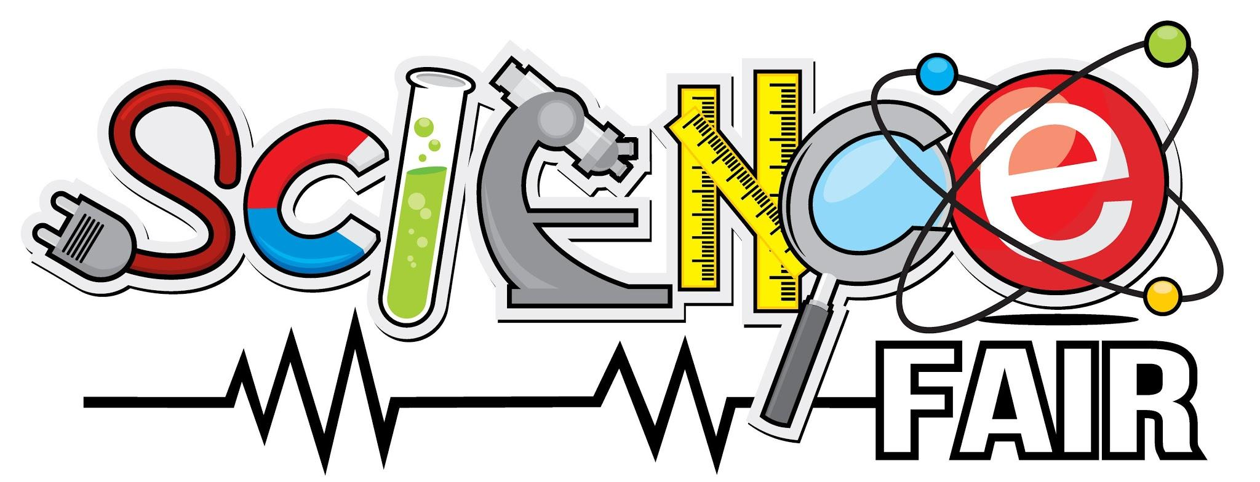

The Science Fair will be held Thursday, March 21, 2019.
Set up time for your project will be announced.

The Big Question:
What is the point of a science fair?
Science fairs allow children to see how science works outside the classroom. Projects allow them to see how a scientist investigates and learns about the world God created. Today, more than ever, students need to understand and appreciate science. Scientific discoveries that affect their lives are happening every day.
“The point of science fairs is to engage the interest of youngsters, encourage them to understand science and possibly look to a career as a scientist or engineer, and help our country maintain the scientific lead and the prosperity of our nation—and perhaps, transfer that prosperity to the whole world.” -Isaac Asimov.
Asimov goes on brilliantly to say that it is the children, who have not yet chosen their lives’ work, on whom we must concentrate, for it is on them that we must rely to continue the technological advancements we need so much. Our children are our greatest resources. This means that our children must be well-educated, well-directed, and well-trained in the understanding of science and technology. The science fair is one way to help get them ready for what lies ahead in their lives.
Getting Started
Entering a science fair is an exciting experience! Perhaps this is because it’s all up to you. You get to decide which project you want to do, gather the materials you need, conduct the experiment, and then enter your project in the fair.

But where do I begin?
- You need to select a topic. The internet has many very useful sites, including...
- https://www.sciencebuddies.org/
- http://www.cool-science-projects.com/
- https://www.education.com/science-fair/
- https://www.sciencefaircentral.com/
You can peruse these sites or just search “science fair projects” and find others.
You will be doing an experiment. For your experiment, keep in mind the following:
  - What is the scientific question you are trying to answer?
  - What observations will you be making?
  - How will you develop a hypothesis?
  - Make sure you follow the scientific method the entire way. Check with your teacher if you are having difficulty deciding on a project or how to do it.
- Once you have your topic and it is narrowed down, you must develop a project around it. To do this, you must have an idea of what your project will accomplish.
In other words...
  - figure out the purpose of your project.
  - develop a plan for carrying out your project.
    - How much time do you have to organize your project?
    - How are you going to gather your information?
    - What kind of an experiment will you conduct?
    - How much time will it take experiment?
- Make sure you keep good notes during your experiment. This will help when you write your paper. When researching (using the library, internet, etc.), keep good notes, too.
Remember, downloading information from the internet or copying word by word from texts and claiming the words are yours is called plagiarism. This is not acceptable.

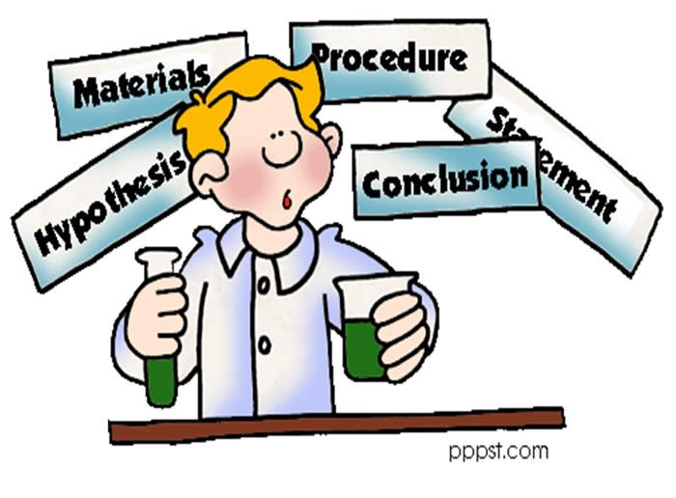
- Organize your work and write your paper.
You will need:
  - Title Page:
    - Project title
    - Your name
    - Grade level
    - Teacher’s name
    - Complete date
  - Purpose: List the purpose of your
project in three sentences or less.
  - Body: Report should contain the research you have done.
Give facts that introduce the subject.
  - Procedure: Explain your experiment step by step and list all the materials used.
  - Results: Give all the logs, graphs, and charts of data for the experiment.
  - Conclusion: Evaluate and interpret the results of the experiment.
Use your data to draw a conclusion about what has been proved or disproved.
Do not be afraid to admit mistakes. Negative results are not bad; if your results
do not support your hypothesis, say so.

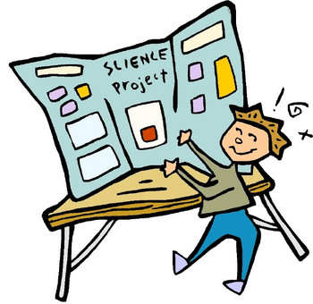
Designing the Visual Presentation
Take time to plan and prepare your display.

- Design a backboard from sturdy, clean materials.
Boards may be purchased through the school for $3.00!
- Choose colors for the display.
Display the title prominently in large letters.
- Mount, tack, pin, or glue all the elements of the science project to the backboard. Use your imagination to make your design appealing. Include such things as diagrams,
photos, charts, and drawings large enough for the viewer to see easily.
Remember that the display board is not the place to hang your entire report.
Your report must be on the table in front of the display.
- Design a report folder with a cover that will interest the viewer in the project. Remember, this is separate from the display board.
A good rule of thumb: Once you have decided what will go on the display board,
lay the whole thing out on the floor and evaluate the arrangement before mounting
the pieces. Make sure things are straight. The judges will look for neatness.

Evaluate Your Own Project
Here a few strategies you can use to evaluate your project:
- I spent the right amount of time on this project. Yes No
- My project is well-planned and organized. Yes No
- I understand my topic and what I am doing. Yes No
- My project stays on the topic I chose. Yes No
- I am using enough sources of information. Yes No
- My project shows creativity. Yes No

Do not wait until the week before to work on this project!
A Word about Awards
It is important to instill in your children a healthy view of competition. Winning is terrific, but it is not the most important part of a science fair project. The enjoyment of working on a project, conducting experiments, exhibiting the work, and discovering science should be the PRIMARY reason for participating in a science fair.
Remind your children that judges are human, and as such, each has a unique perspective. Their view may be different than yours. Even if you think your project is perfect, the judges may see ways it could be improved. This may be difficult to accept, but it is part of the learning process. The judges will be following judging criteria.
Evaluate your own project with this sheet… be honest.
Make sure you have followed all the rules and procedures. You should do well.

Grading Criteria
Each student is required to do a science fair project and will be evaluated by his or her classroom teacher. Teachers will be viewing their students’ projects and will evaluate them before the judges see them. Grades for the projects, therefore, cannot and will not be based on the ribbon earned. Each teacher knows the ability level of each student. A participation ribbon does not necessarily reflect the amount of effort put into a project. The red, white, and blue ribbons are used to recognize the projects that have met all established criteria and show outstanding effort. Projects that earn red, white, or blue ribbons are neat, well-organized, and follow all directions.

Science Fair Rules
- Each project must be related to an area of Science (not Social Studies).
- Each project will be displayed within the appropriate grade level.
- The acceptable Science category is: experiment.
- A contestant may enter only ONE project.
  - Teachers and parents may advise.
  - They may not put together the display, but may give ideas
which help the student present a creative and neat project.
  - Parents may not write the research paper, but may type it.
  - In grades 1-3 the parents may help with the writing, but it should
be age appropriate and definitely understood by the child.
It is purposeless to write a paper that is not understood by your child.
- Projects must be free standing, no wider than 30” and have a depth no more than 28”. The project may not infringe on any other project’s space. This could cause a loss of points on your overall score.
- Safety precautions must be followed.
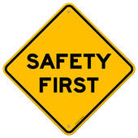
  - The following are prohibited: dangerous chemicals, open flames, explosives, animal experiments involving starvation or cruelty, sharp objects.
  - Any small objects that could be swallowed by a young child need
to be securely fastened to the display board.
  - No breakable containers.
  - No animals may be on display.
  - All samples of smelly items (i.e. mold or decaying materials)
must be in tightly sealed non-breakable containers.
- The school and teachers assume no responsibility for loss or damage to any exhibit or any part thereof. Do not display something that you consider a family treasure or a highly popular item (Webkinz, etc.) if you don’t want it touched.
If the project is not picked up after the science fair, it will be disposed of.
This includes all parts of the project. This does include the ribbons, as well, which may
be recycled for the next science fair. Do not expect to get your ribbons if left behind.
- The classroom teacher will be informed about any project that is removed prior to public viewing. This will affect your classroom grade.
- All entrants will receive a ribbon for participation.
There will be additional ribbons for outstanding projects within each grade level.
Remember, in order to receive an additional ribbon the project must meet all general criteria and receive high scores from the judges.
- All the judges are qualified to evaluate science projects. Their decisions are final.
- The impact of the science fair project on your science grade is determined by your classroom teacher.
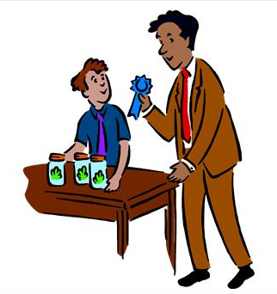
Criteria for Judging
- Report (30 points)
  - Includes complete background research.
  - Explains the hypothesis
and the procedures used.
  - Data is clearly recorded.
  - Is clear, uses proper spelling and grammar.
  - Is neat.

- Scientific Procedures (25 points)
  - States the problem being investigated.
  - Formulates a hypothesis.
  - Follows the Scientific Method to test hypothesis.
  - Records observations and measurements.
  - Analyzes data accurately.
  - Draws a conclusion based on observations and data.

- Clarity (20 points)
  - Observer can easily understand what has been done.

- Display (25 points)
  - Display is neat, attractive and colorful.
  - Everything is clearly labeled.
  - Display is well constructed and sturdy.

Total points: 100 points

